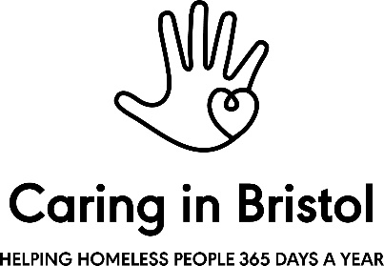

Youth Key Worker - Person Specification

All criteria are essential unless otherwise stated

Attributes and personal qualities
- A passion for working with young people and a belief in the power of relationship-led practice as a tool for change;
- Excellent relational skills and the ability to handle sensitive and challenging issues with patience, tact and diplomacy;
- Creative and uses initiative. Open to challenge, embraces problem solving;
- Enthusiastic and positive, able to come up with innovative ideas and see these through into projects;
- A great communicator and team player, passionate about working with others to get things done;
- Self-confident and practical, able to take ownership and drive tasks to completion, seeking support where needed;
- Excellent attention to detail;
- High levels of emotional resilience;
- A sense of playfulness and humour to meet the engagement needs of adolescents.

Skills and experiences
- An understanding of adolescence, particularly in the context of unaddressed childhood adversity and unmet emotional difficulties;
- Ability to work in partnership with a variety of agencies, advocating for young people and brokering support for them;
- Experience of working individually and in group settings with young people;
- Proven ability to be responsive to need as it arises, including moments of emotional dysregulation and crisis for young people;
- Ability and willingness to engage in teamwork and to support the creation of a collective culture and values base for the project;
- Knowledge and understanding of legislation around safeguarding, in the areas of both children and adults;
- Good verbal and written communication skills and the ability to write accurate reports;
- Experience of managing and recruiting volunteers (desirable)
- Level 4 qualification in a related field (Youth Work, Education or Social Work) desirable, although relevant experience of direct work with young people will be considered (desirable);
- Therapeutic qualifications and experience (desirable);
- Understanding of restorative justice models (desirable);
- Ability to bring practical or artistic skills to your key worker role to share with young people (desirable);
- Understanding of the complexities of youth homelessness legislation and practice (desirable);
- Previous experience of fundraising or bid writing (desirable).

Other:
- Willingness to engage in regular reflective practice, including clinical supervision
- Willingness to be on our out of hours calls rota, and to occasionally work unsociable hours.

