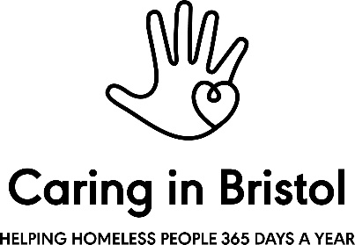
Caring in Bristol Monitoring Form

EQUAL OPPORTUNITY

WHAT BEST DESCRIBES YOUR GENDER? *
IF YOU PREFER TO SELF-DESCRIBE PLEASE PROVIDE THIS HERE:
DO YOU IDENTIFY AS TRANS? *
WHAT IS YOUR SEXUAL ORIENTATION? *
IF YOU PREFER TO SELF-DESCRIBE PLEASE PROVIDE THIS HERE:
DO YOU CONSIDER YOURSELF TO HAVE A DISABILITY? *

REASONABLE ADJUSTMENTS

The Equality Act 2010 requires all employers to make reasonable adjustments for disabled employees.
Caring in Bristol uses the social model to inform disability action planning. This means concentrating on the environment, removing barriers wherever possible that get in the way of a disabled person from doing their job. Should you be successful in your appointment to the post, do you require any reasonable adjustments to be put in place?
Please specify in the box below:

AGE *
ETHNICITY *

IF OTHER ETHNIC GROUP OR IF YOU PREFER TO USE YOUR OWN TERM PLEASE PROVIDE THIS HERE:
RELIGION AND BELIEF *
IF YOU PREFER TO USE YOUR OWN DEFINITION PLEASE PROVIDE THIS HERE

ADVERTISING EFFECTIVENESS

YOUR  NAME: |  |  | JOB APPLIED  FOR :

Caring in Bristol internally monitors the effectiveness/impact of advertising vacancies and is constantly seeking to put the various forms of advertising to the best use to attract as diverse a range of candidates as possible.
We recognise that you may have learnt about the vacancy from various sources, but it helps us to know how you became aware of this vacancy.
HOW DID YOU GET DETAILS OF THIS VACANCY? Please specify in the box below:

